|  |  |
| --- | --- |
|  | Project: Proposal |
|  | Assessment 1: |
|  | Mitchell Bellamy (BEL13374080)  Project (CMP3060M)  10/16/15 |

Contents

1. Introduction 2

1.1. OBS Plugin to overlay key presses 2

1.2. Research Methods 2

1.3. Tools 2

2. Aims and Objectives 3

2.1. Aim 3

2.2. Objective - 3

3. Literature Review 4

3.1. 4

3.2. 4

4. Project Plan 5

4.1. Direction of the project 5

4.2. Gantt Chart 5

4.3. Risk Matrix 5

5. References 6

# 1. Introduction

## 1.1. Project Domain and Rationale

This project involves elements of software development, open source integration, human-computer interaction and design. Many of these aspects will be tackled in some way throughout the introduction and explained as to why they are important areas for the project and what will be done to fulfil them.

It is these aspects and the ability to produce a deliverable to users across the globe that made this project desirable. On top of that, it provides good grounds to gain experience of working in the open source sector of industry which can improve employability and software knowledge.

This project outlines the requirement to develop a plugin (software) for Open Broadcaster Software (OBS). OBS is a program that allows the user to stream a video feed live to the internet (through services such as Twitch.tv and Livestream.com). This plugin is to display relevant keystroke information to viewers of the stream.

## 1.2. OBS Plugin to overlay key presses

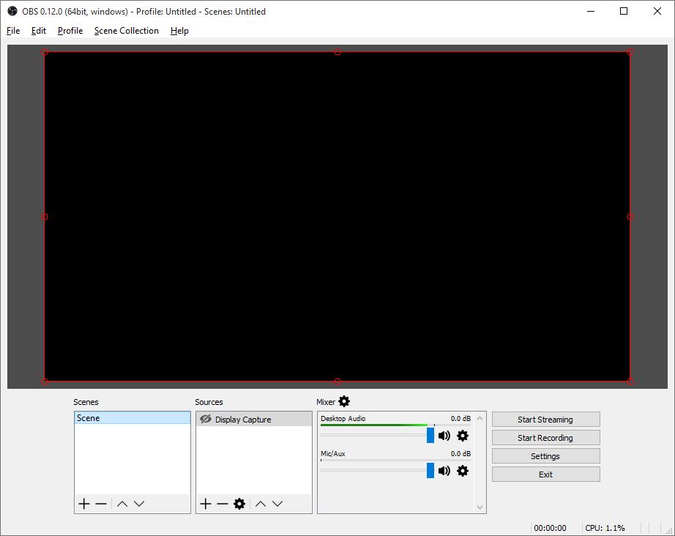Open Broadcaster Software (OBS) is an open source program developed for people to record and/or live stream video from their computer to services such as Twitch.tv and livestream.com. The use case scenarios are vast for live streaming, such as festivals, talk shows, games, podcasts and more. In particular, live streaming from home on a computer has become exceptionally popular with consumers and content creators over the last couple of years (citation needed). This high growth and uncertain future makes the streaming community a very interesting area for new research and development.

Figure : OBS Studio 0.12 on Windows.

OBS Studio allows the user to both stream and record video. More uniquely, is that as a streaming software package, it offers ‘scenes’ and ‘sources’ which can help create independent windows to help separate what the streamer sees on their computer to what the viewers see online. This is something that will need to be considered and incorporated to help empathise with the viewers and users independently.

Even now ‘live streaming’ video games in particular can be a very heated topic. There are many who believe ‘e-sports’ are now mainstream or soon to be widely accepted (citation needed). The community surrounding just e-sports are extremely passionate and consistently consume this media. One of the more interesting growth areas for this project to look into however is those that watch professional players to learn how to play better for themselves. Furthermore, for those that record tutorial videos with OBS for computer software for example, have very limited options in displaying shortcuts or key presses to help viewers learn more efficiently. These are just two scenarios that would benefit from a plugin to overlay key presses during live streaming and recording.

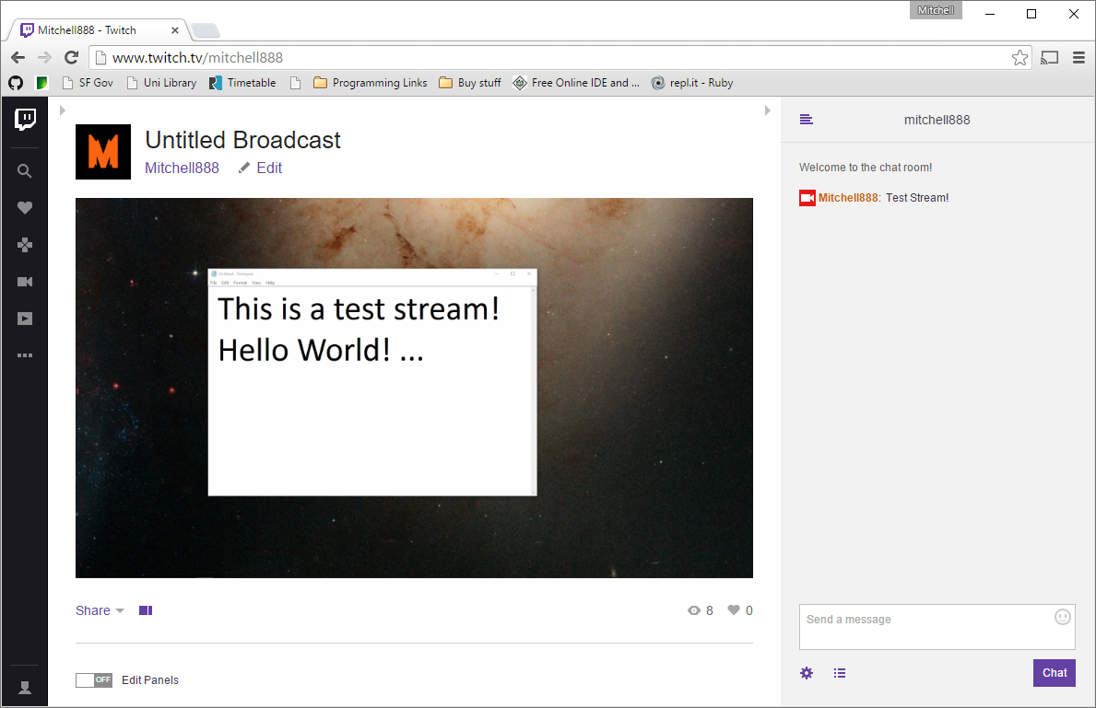Twitch.tv is just one of the many services that offer to host live streaming, along with YouTube and Livestream.com. Twitch.tv however has a primary focus on gaming and related content (such as music, software and talk shows). YouTube also has a live streaming sub-site which focuses on gaming content only, whereas Livestream.com aims to host live events.

Figure : A quick test stream on Twitch.tv

For this project, Livestream.com is somewhat out of scope as it is unlikely that live events would benefit from a key overlay. Therefore, the aim of this project will target services similar to and including Twitch.tv. This helps to define a domain and scope for the aim, which will help to create potential focus groups or for testing purposes.

As for the plugin itself which is to be developed in C++ on the latest version of OBS Studio, will be required to effectively display relevant keystrokes to the viewer but not overlay this information on the streamers machine as to avoid distraction and clutter. The streamer will always be able to see what the viewers see through OBS Studio itself.

The design of the key overlay needs to display information in such a way that is helpful to viewers so that they can follow the streamers actions (and reactions) in a way that has not been possible before. The display of this information is something that will need to be researched, trialled and tested to ensure it delivers the aim to the viewers.

## 1.2. Research Methods

Ethnography, Observation of Streaming and use of software.

Interviews, including Focus Groups.

Emulating user, learn how to use OBS/Studio

Previous plugins/workarounds

Other Programs and their plugins: Blender

## 1.3. Tools

OBS and the community forums

Visual Studio

Cmake

# 2. Aims and Objectives

## 2.1. Aim

The aim of this project is to develop a plugin which enables a streamer to display their corresponding keystrokes live to their viewers.

For e-sports enthusiasts, gamers and spectators.

For viewers of software based tutorials.

Focus on Twitch.tv and other gaming related streaming sites.

## 2.2. Objectives

Outline design of key overlay: How should it *look*?

Required features

Development environment

Ethical issues

User success

Research and testing

Feature list

2.3. Extended Objectives

Potential Features

# 3. Literature Review

## 3.1.

//supports chosen aim and provides context

Discuss;

Ergonomics

Similar products

Similar plugins

Adding more information to a stream

E.g. adding text into a video byte stream.

## 3.2.

//contributes to the chosen methods/tools/techniques

HCI related literature on Ethnography/Observation and Interviews.

# 4. Project Plan

## 4.1. Direction of the project

## 4.2. Gantt Chart

## 4.3. Risk Matrix

|  |  |  |  |
| --- | --- | --- | --- |
| **Risk** | **Likelihood** | **Impact** | **Mitigation** |
| Personally being ill or unable to work. | Low | Due to the nature of this project being predominately desk based, the impact will be minimal. | Ensure work is not done in bulk, but progressively each week. |
| Delays and issues to setting up Plugin Development. | High | Until this hurdle is overcome, it could have a medium-high impact on the start of the project. | Abundance of open source assistance available and University staff to assist if needed. |
| Supervisor unavailable due to illness | Moderate | As the project spans for several months, it is moderately likely that the supervisor may be unable to attend a meeting or respond appropriately due to illness. | Ensuring that work moves at a consistent steady pace so that any one meeting does not become more critical than another. |
| OBS Studio Development Issues | High | Slowed development and harder implementations of features and cross-platform compatibility. Moderate impact. | Target only Windows initially to ensure at least one version works. Join the Open community as documentation is lacking. |
| CMake Development issues | Moderate | Slower initial development until it has been setup. Minimal impact. | Assistance with Supervisor and online Documentation to speed up the process. |
| Problematic implementation | High | It is very likely that implementing a particular function/feature will be almost impossible due to how new OBS Studio is, and that it is not feature complete. | This will have to be mitigated by developing workarounds or simply putting features on hold until development progresses. |
| Home computer breaks. | Low | Low impact to work however the schedule and plan may need to adapt. | GitHub repository and OneDrive will keep independent copies to ensure there is no data loss to work, including documentation. |
| Updates to OBS Studio cause issues to plugin | Moderate | Moderate impact, unforeseen updates may create new roadblocks for development. | If this becomes too big of an issue, development may have to be kept on one version until OBS matures. |
| Unable to implement full plugin within OBS Studio | Low | High impact, the project will have to target another version or stand alone. | If this occurs, then development will need to target an old version of OBS or write a standalone program. |
| Loss of work. | Low | High impact. | All associated work (including the artefact) will be stored on a private repo on GitHub and OneDrive. |
| Missed objective deadlines. | Low | Moderate Impact | Development for certain objectives may take longer to implement due to bad estimations or unforeseen issues, avoiding these where possible. |
| Users dislike the final artefact product | Low | High Impact to success of plugin, but will still yield useful results. | To prevent the final product from not fulfilling the aim confidently, testing and research will be done frequently as iterations are created. |

# 5. References

**There are no sources in the current document.**

Twitch.tv statistics and boast pages:

<http://www.twitch.tv/year/2014>

<http://www.twitch.tv/year/2013>

* <http://www.businessinsider.com/statistics-about-twitch-2014-8?IR=T>

<http://bambooinnovator.com/2014/02/04/apple-quietly-builds-new-networks-stitching-together-a-network-of-internet-infrastructure-capable-of-delivering-large-amounts-of-content-to-customers-giving-the-company-more-control-over-the-distrib>

* 1.8% internet traffic compared to Apple, google, Netflix.

Other products:

<http://www.tobii.com/xperience/>

* Eye tracking.

Other plugins: (not OBS Studio)

<https://obsproject.com/forum/threads/tool-streamkb-onscreen-keyboard.4789/>

<https://obsproject.com/forum/threads/nohboard.12637/>

<https://www.youtube.com/watch?v=FB8bFf__kjg>

* Also in: <https://www.youtube.com/watch?v=L4xEhEsju8o>

Streamers:

<http://www.twitch.tv/spareosu/v/23311853>

* A streamer using two webcams to show keypresses